Inter-VLAN Communication



Huawei Technologies Co., Ltd.

|  |
| --- |
| **Copyright © Huawei Technologies Co., Ltd. 2020. All rights reserved.**  No part of this document may be reproduced or transmitted in any form or by any means without prior written consent of Huawei Technologies Co., Ltd.  **Trademarks and Permissions**  HW_POS_RBG_Vertical-150ppi.png and other Huawei trademarks are trademarks of Huawei Technologies Co., Ltd.  All other trademarks and trade names mentioned in this document are the property of their respective holders.  **Notice**  The purchased products, services and features are stipulated by the contract made between Huawei and the customer. All or part of the products, services and features described in this document may not be within the purchase scope or the usage scope. Unless otherwise specified in the contract, all statements, information, and recommendations in this document are provided "AS IS" without warranties, guarantees or representations of any kind, either express or implied.  The information in this document is subject to change without notice. Every effort has been made in the preparation of this document to ensure accuracy of the contents, but all statements, information, and recommendations in this document do not constitute a warranty of any kind, express or implied. |

|  |  |
| --- | --- |
| Huawei Technologies Co., Ltd. | |
| Address: | Huawei Industrial Base  Bantian, Longgang  Shenzhen 518129  People's Republic of China |
| Website: | <https://e.huawei.com/> |

**Huawei Certification System**

Huawei Certification follows the "platform + ecosystem" development strategy, which is a new collaborative architecture of ICT infrastructure based on "Cloud-Pipe-Terminal". Huawei has set up a complete certification system consisting of three categories: ICT infrastructure certification, platform and service certification, and ICT vertical certification. It is the only certification system that covers all ICT technical fields in the industry. Huawei offers three levels of certification: Huawei Certified ICT Associate (HCIA), Huawei Certified ICT Professional (HCIP), and Huawei Certified ICT Expert (HCIE). Huawei Certification covers all ICT fields and adapts to the industry trend of ICT convergence. With its leading talent development system and certification standards, it is committed to fostering new ICT talent in the digital era, and building a sound ICT talent ecosystem.

Huawei Certified ICT Associate-Datacom (HCIA-Datacom) is designed for Huawei's frontline engineers and anyone who want to understand Huawei's datacom products and technologies. The HCIA-Datacom certification covers routing and switching principles, basic WLAN principles, network security basics, network management and O&M basics, SDN and programmability and automation basics.

The Huawei certification system introduces the industry, fosters innovation, and imparts cutting-edge datacom knowledge.

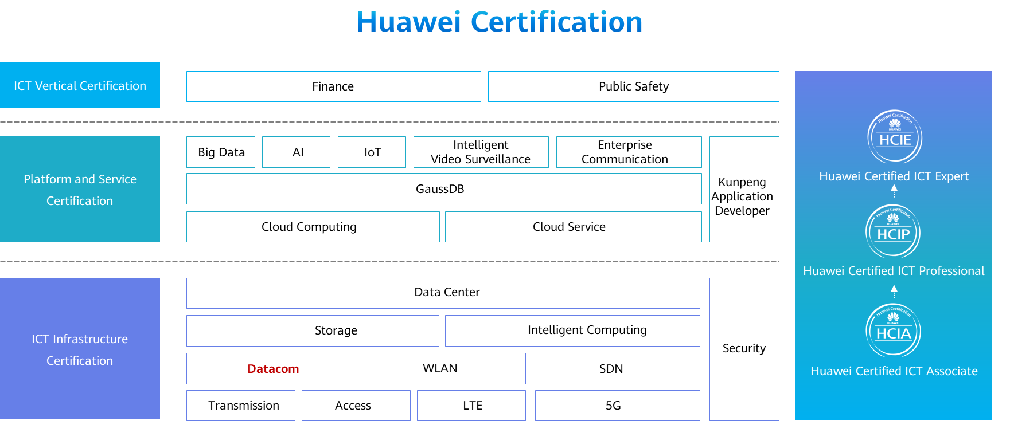

Contents

[1 Inter-VLAN Communication 1](#_Toc60149045)

[1.1 Foreword 1](#_Toc60149046)

[1.2 Objectives 1](#_Toc60149047)

[1.3 Background 1](#_Toc60149048)

[1.3.1 Inter-VLAN Communication 1](#_Toc60149049)

[1.4 Using Routers' Physical Interfaces or Sub-interfaces to Implement Inter-VLAN Communication 3](#_Toc60149050)

[1.4.1 Using a Router's Physical Interfaces 3](#_Toc60149051)

[1.4.2 Using a Router's Sub-interfaces 4](#_Toc60149052)

[1.4.3 Sub-Interface Processing 5](#_Toc60149053)

[1.4.4 Example for Configuring Sub-interfaces 5](#_Toc60149054)

[1.5 Using VLANIF Interfaces to Implement Inter-VLAN Communication 7](#_Toc60149055)

[1.5.1 Layer 3 Switch and VLANIF Interfaces 7](#_Toc60149056)

[1.5.2 Example for Configuring VLANIF Interfaces 8](#_Toc60149057)

[1.5.3 VLANIF Forwarding Process 9](#_Toc60149058)

[1.6 Layer 3 Communication Process 12](#_Toc60149059)

[1.6.2 Communication Process (1) 13](#_Toc60149060)

[1.6.3 Communication Process (2) 13](#_Toc60149061)

[1.6.4 Communication Process (3) 14](#_Toc60149062)

[1.6.5 Communication Process (4) 15](#_Toc60149063)

[1.7 Summary 15](#_Toc60149064)

[1.8 Quiz 15](#_Toc60149065)

# Inter-VLAN Communication

## Foreword

By default, a Layer 2 switching network is a broadcast domain, which brings many problems. Virtual local area network (VLAN) technology isolates such broadcast domains, preventing users in different VLANs from communicating with each other. However, such users sometimes need to communicate.

This course describes how to implement inter-VLAN communication.

Inter-VLAN Communication

## Objectives

On completion of this course, you will be able to:

Methods of implementing inter-VLAN communication.

How to use routers (physical interfaces or sub-interfaces) to implement inter-VLAN communication.

How to use Layer 3 switches to implement inter-VLAN communication.

How Layer 3 packets are forwarded.

## Background

### Inter-VLAN Communication

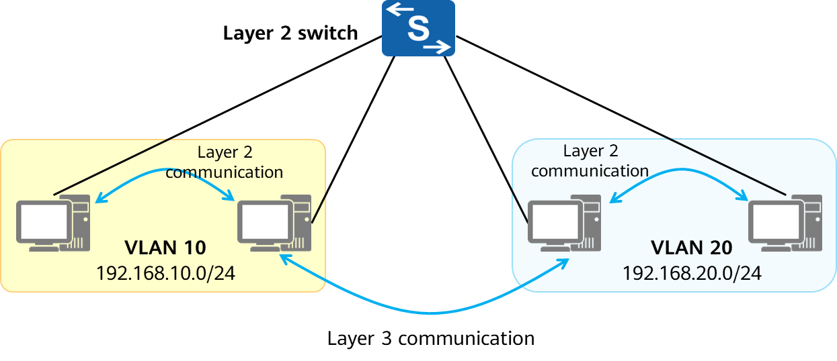

Inter-VLAN Communication

In real-world network deployments, different IP address segments are assigned to different VLANs.

PCs on the same network segment in the same VLAN can directly communicate with each other without the need for Layer 3 forwarding devices. This communication mode is called Layer 2 communication.

Inter-VLAN communication belongs to Layer 3 communication, which requires Layer 3 devices.

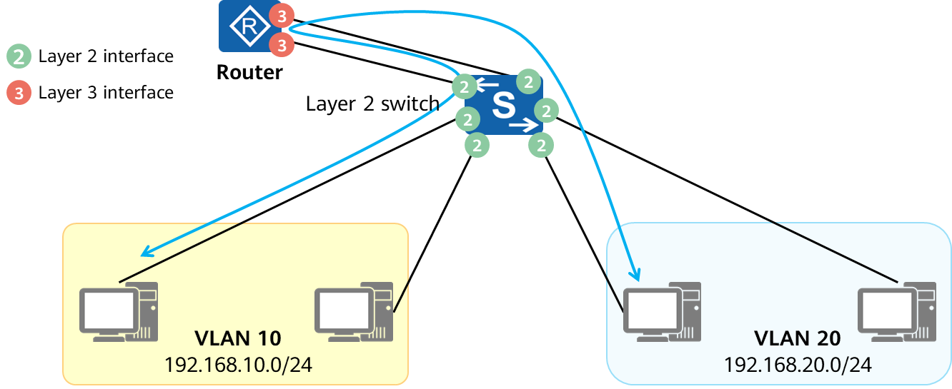

Inter-VLAN Communicating By Layer-3 Device

Common Layer 3 devices: routers, Layer 3 switches, firewalls, etc.

Inter-VLAN communication is implemented by connecting a Layer 2 switch to a Layer 3 interface of a Layer 3 device. The communication packets are routed by the Layer 3 device.

## Using Routers' Physical Interfaces or Sub-interfaces to Implement Inter-VLAN Communication

### Using a Router's Physical Interfaces

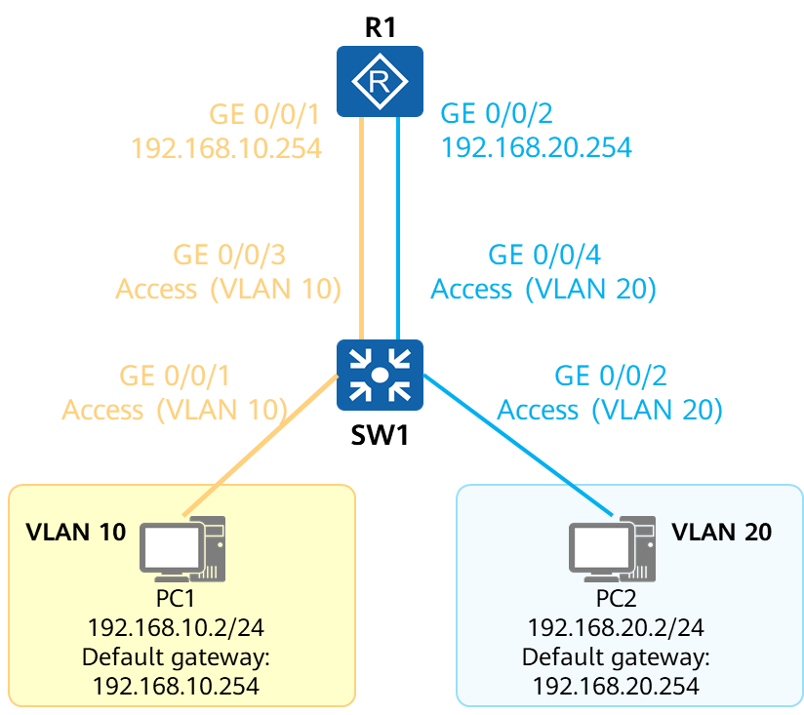

Physical Connection of Inter-VLAN communicating By Router

The Layer 3 interfaces of the router function as gateways to forward traffic from the local network segment to other network segments.

The Layer 3 interfaces of the router cannot process data frames with VLAN tags. Therefore, the interfaces of the switch connected to the router must be set to the access type.

One physical interface of the router can function as the gateway of only one VLAN, meaning that the number of required physical interfaces are determined by the quantity of the deployed VLANs.

A router, mainly forwarding packets at Layer 3, provides only a small number of physical interfaces. Therefore, the scalability of this solution is poor.

Configure VLANs on the Layer 2 switch. Each VLAN uses an independent switch interface to connect to the router.

The router provides two physical interfaces as the default gateways of PCs in VLAN 10 and VLAN 20, respectively, for the PCs to communicate with each other.

### Using a Router's Sub-interfaces

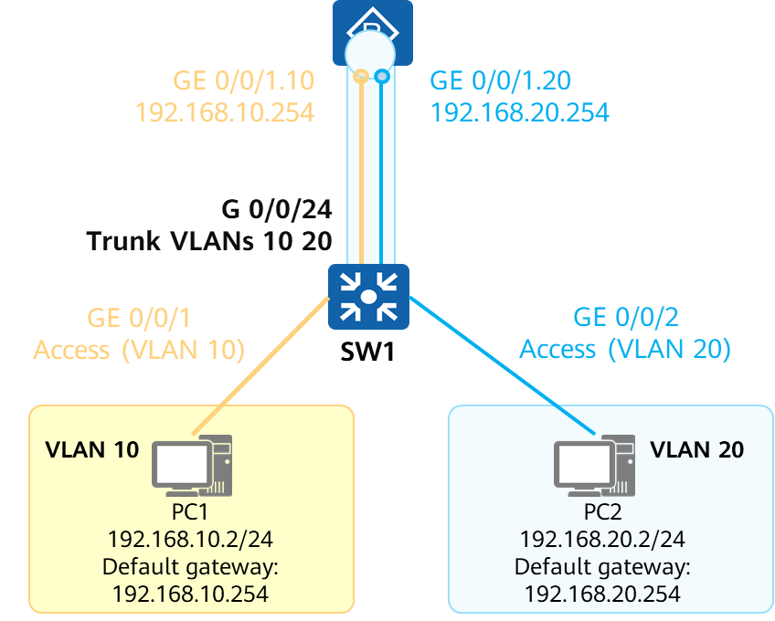

Physical Connection of Inter-VLAN communicating By Router’s Sub-interface

A sub-interface is a logical interface created on a router's Ethernet interface and is identified by a physical interface number and a sub-interface number. Similar to a physical interface, a sub-interface can perform Layer 3 forwarding.

Different from a physical interface, a sub-interface can terminate data frames with VLAN tags.

You can create multiple sub-interfaces on one physical interface. After connecting the physical interface to the trunk interface of the switch, the physical interface can provide Layer 3 forwarding services for multiple VLANs.

R1 connects to SW1 through a physical interface (GE 0/0/1). Two sub-interfaces (GE 0/0/1.10 and GE 0/0/1.20) are created on the physical interface and used as the default gateways of VLAN 10 and VLAN 20, respectively.

Layer 3 sub-interfaces do not support VLAN packets and discard them once received. To prevent this issue, the VLAN tags need to be removed from the packets on the sub-interfaces. That is, VLAN tag termination is required.

### Sub-Interface Processing

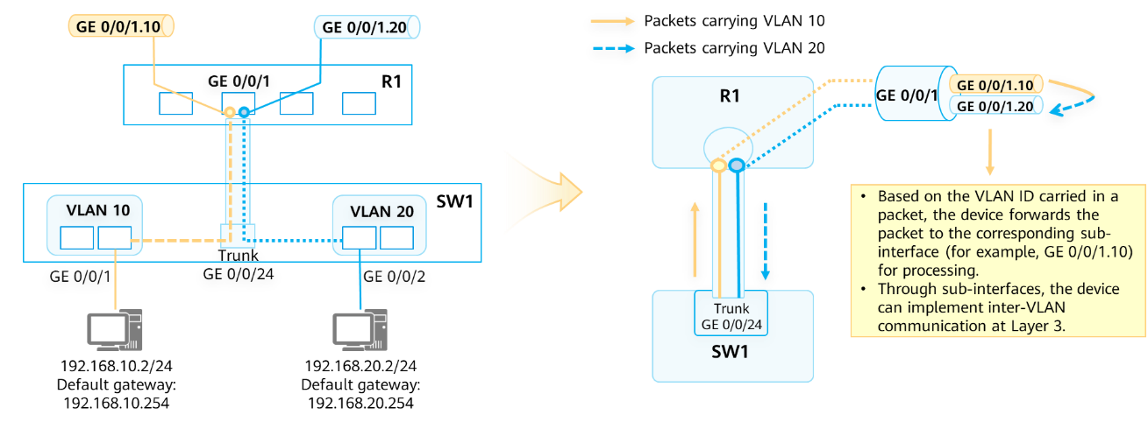

Sub-Interface Processing

The interface connecting the switch to the router is set to a trunk interface. The router forwards the received packets to the corresponding sub-interfaces according to the VLAN tags in the packets.

A sub-interface implements VLAN tag termination as follows:

1. Removes VLAN tags from the received packets before forwarding or processing the packets.
2. Adds VLAN tags to the packets before forwarding the packets.

### Example for Configuring Sub-interfaces

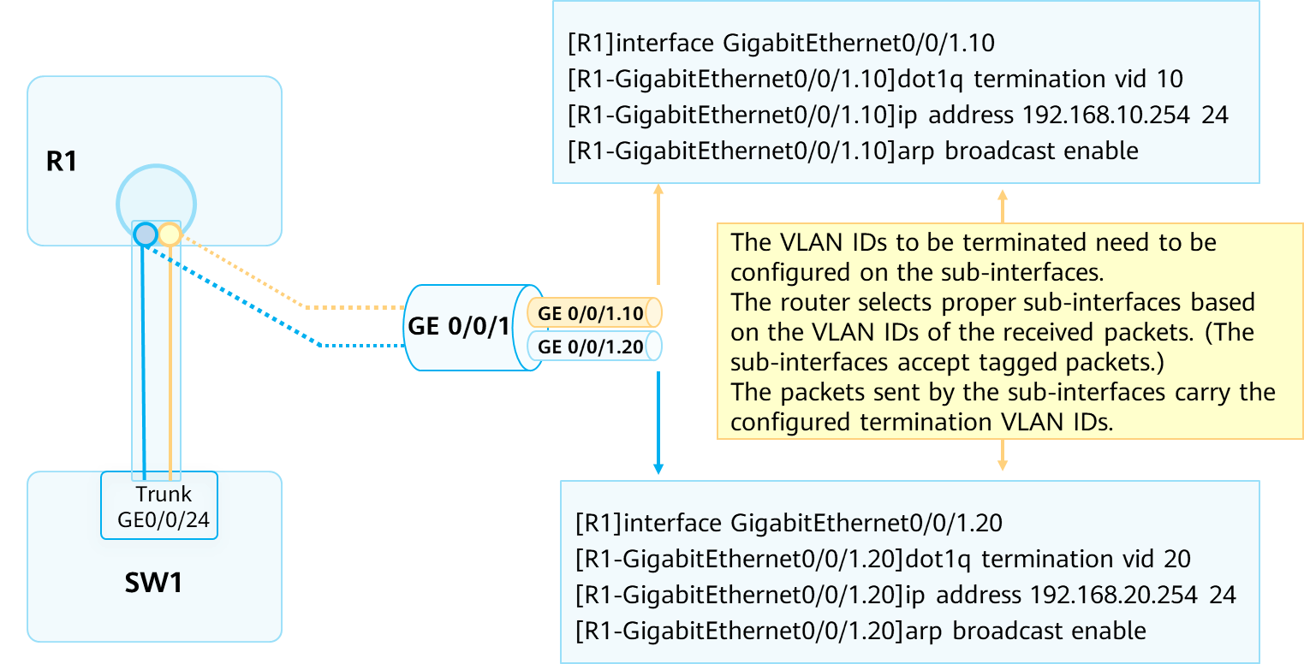

Example for Configuring Sub-interfaces

The interface interface-type interface-number.sub-interface number command creates a sub-interface. sub-interface number specifies the number of a sub-interface on a physical interface. For easy memorization, a sub-interface number is generally the same as the VLAN ID to be terminated on the sub-interface.

The dot1q termination vid command enables Dot1q VLAN tag termination for single-tagged packets on a sub-interface. By default, Dot1q VLAN tag termination for single-tagged packets is not enabled on sub-interfaces. The arp broadcast enable command enables ARP broadcast on a VLAN tag termination sub-interface. By default, ARP broadcast is not enabled on VLAN tag termination sub-interfaces. VLAN tag termination sub-interfaces cannot forward broadcast packets and automatically discard received ones. To allow a VLAN tag termination sub-interface to forward broadcast packets, run the arp broadcast enable command.

## Using VLANIF Interfaces to Implement Inter-VLAN Communication

### Layer 3 Switch and VLANIF Interfaces

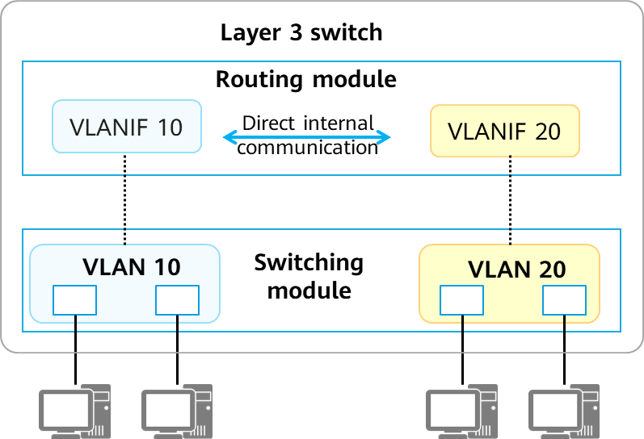

Diagram of Layer 3 switch

A Layer 2 switch provides only Layer 2 switching functions.

A Layer 3 switch provides routing functions through Layer 3 interfaces (such as VLANIF interfaces) as well as the functions of a Layer 2 switch.

A VLANIF interface is a Layer 3 logical interface that can remove and add VLAN tags. VLANIF interfaces therefore can be used to implement inter-VLAN communication.

A VLANIF interface number is the same as the ID of its corresponding VLAN. For example, VLANIF 10 is created based on VLAN 10.

### Example for Configuring VLANIF Interfaces

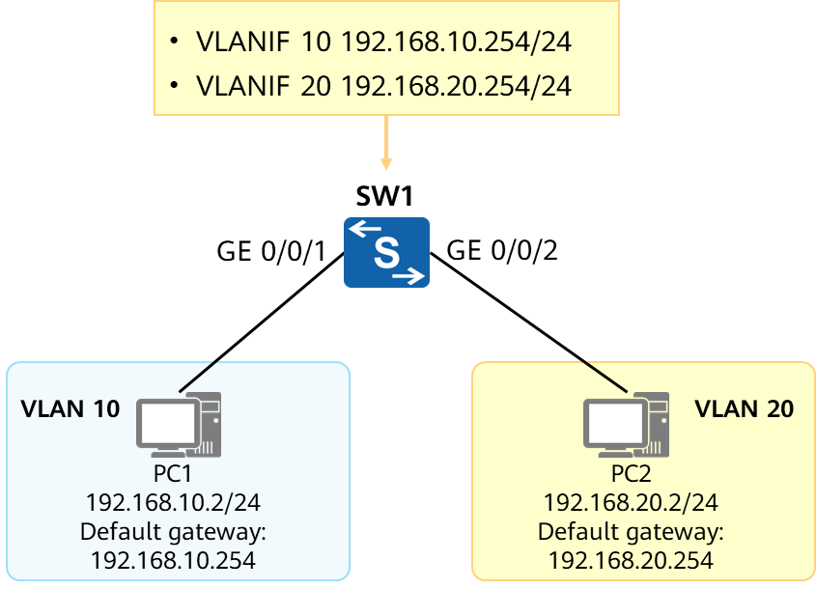

Diagram of configuring VLANIF interface

Configuration Requirements:

* Configure VLANs 10 and 20 for the interfaces connecting to PC1 and PC2, respectively. Configure the Layer 3 switch to allow the two PCs to communicate with each other.

Basic configurations:

[SW1]vlan batch 10 20

[SW1] interface GigabitEthernet 0/0/1

[SW1-GigabitEthernet0/0/1] port link-type access

[SW1-GigabitEthernet0/0/1] port default vlan 10

[SW1] interface GigabitEthernet 0/0/2

[SW1-GigabitEthernet0/0/2] port link-type access

[SW1-GigabitEthernet0/0/2] port default vlan 20

Configure VLANIF interfaces:

[SW1]interface Vlanif 10

[SW1-Vlanif10]ip address 192.168.10.254 24

[SW1]interface Vlanif 20

[SW1-Vlanif20]ip address 192.168.20.254 24

The interface vlanif vlan-id command creates a VLANIF interface and displays the VLANIF interface view. vlan-id specifies the ID of the VLAN associated with the VLANIF interface. The IP address of a VLANIF interface is used as the gateway IP address of a PC and must be on the same network segment as the IP address of the PC.

### VLANIF Forwarding Process

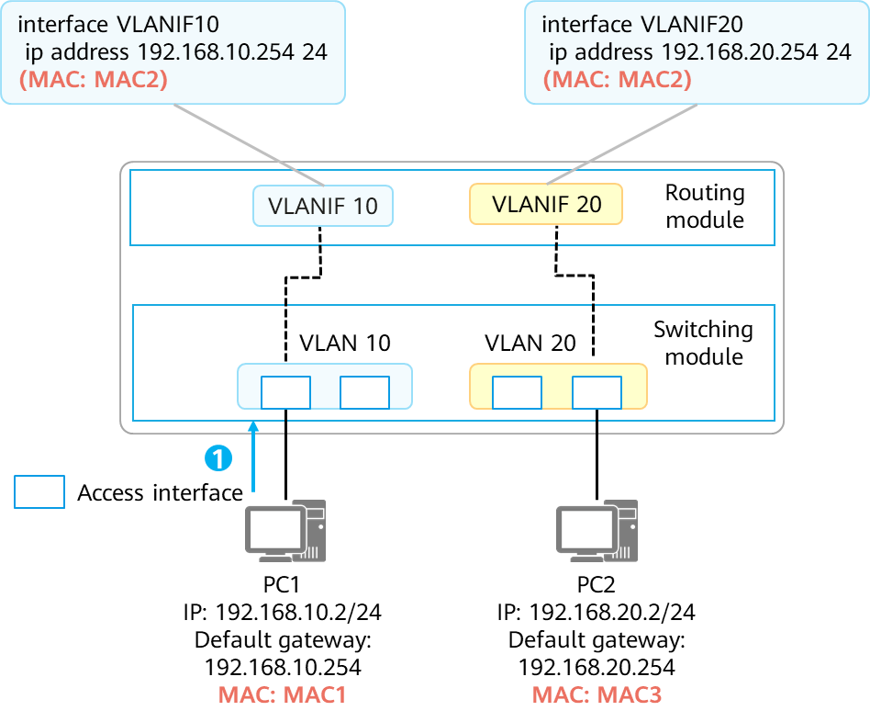

Step 1 of VLANIF Forwarding Process

This example assumes that the required ARP or MAC address entries already exist on the PCs and the Layer 3 switch.

The communication process between PC1 and PC2 is as follows:

* PC1 performs calculation based on its local IP address, local subnet mask, and destination IP address, and finds that the destination device PC2 is not on its network segment. PC1 then determines that Layer 3 communication is required and sends the traffic destined for PC2 to its gateway. Data frame sent by PC1: source MAC = MAC1, destination MAC = MAC2

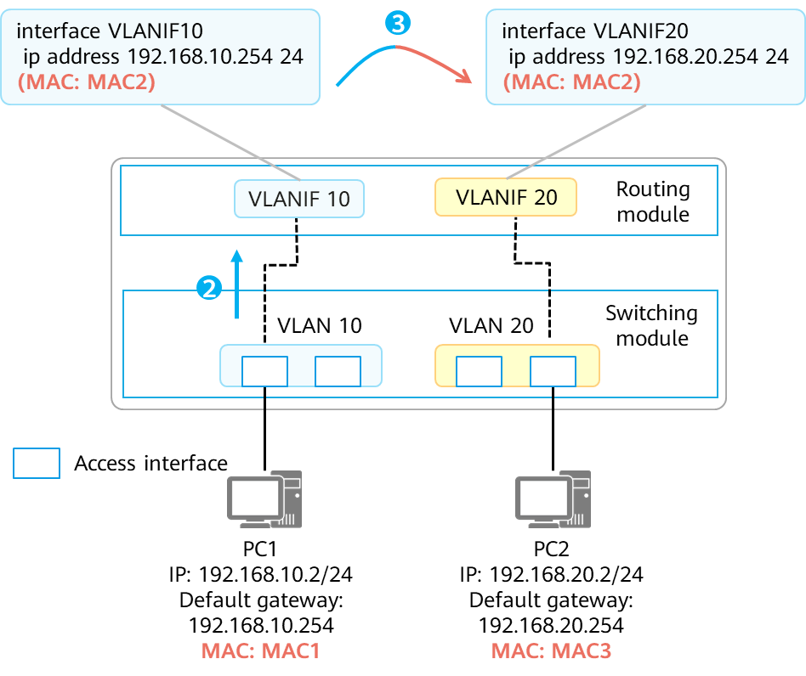

Step 2,3 of VLANIF Forwarding Process

* After receiving the packet sent from PC1 to PC2, the switch decapsulates the packet and finds that the destination MAC address is the MAC address of VLANIF 10. The switch then sends the packet to the routing module for further processing.
* The routing module finds that the destination IP address is 192.168.20.2, which is not the IP address of its local interface, and determines that this packet needs to be forwarded at Layer 3. By searching the routing table, the routing module finds a matching route – the direct route generated by VLANIF 20 – for this packet.

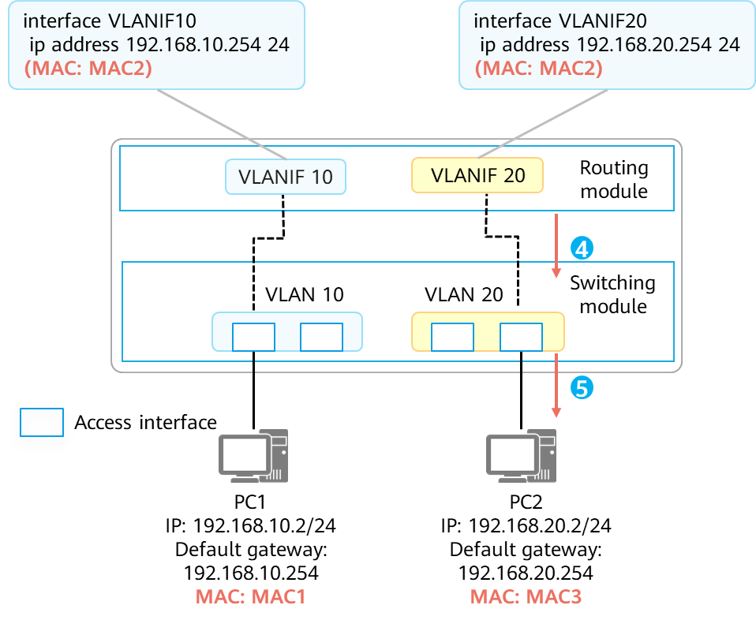

Step 4,5 of VLANIF Forwarding Process

* Because the matching route is a direct route, the switch determines that the packet has reached the last hop. It searches its ARP table for 192.168.20.2, obtains the corresponding MAC address, and sends the packet to the switching module for re-encapsulation.
* The switching module searches its MAC address table to determine the outbound interface of the frame and whether the frame needs to carry a VLAN tag. Data frame sent by the switching module: source MAC = MAC2, destination MAC = MAC3, VLAN tag = None.

## Layer 3 Communication Process

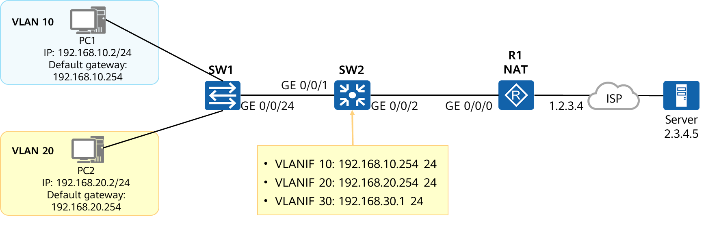

Diagram of L3 communication Process

This topology is used as an example to describe the communication process from PC1 in VLAN 10 to the server (2.3.4.5) on the Internet.

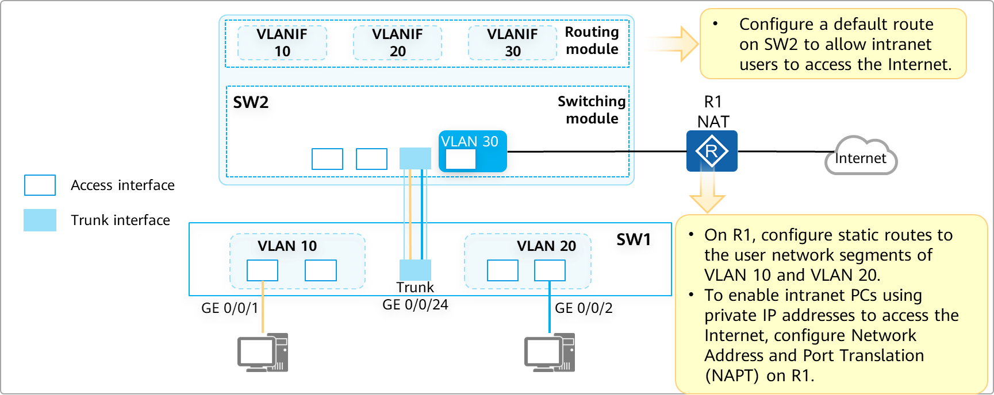

Logical Connection

NAPT: translates the IP address and port number in an IP packet header to another IP address and port number. NAPT is mainly used to enable devices on an internal network (private IP addresses) to access an external network (public IP addresses). NAPT allows multiple private IP addresses to be mapped to the same public IP address. In this way, multiple private IP addresses can access the Internet at the same time using the same public IP address.

### Communication Process (1)

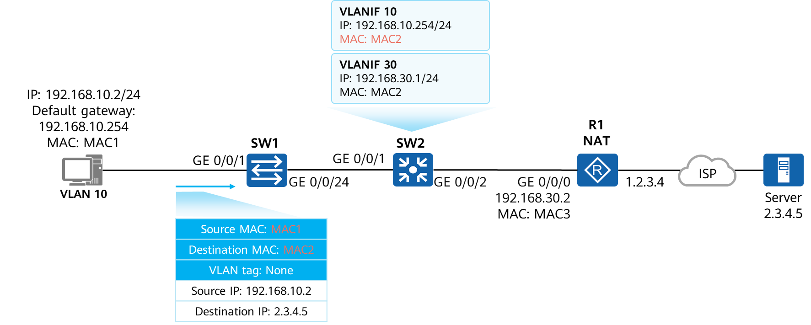

Communication Process (1)

This example assumes that the required ARP or MAC address entries already exist on all devices.

First of all,the PC process:

Before sending a packet to 2.3.4.5, the PC sends the packet to its gateway after determining that the destination IP address is not on its network segment.

### Communication Process (2)

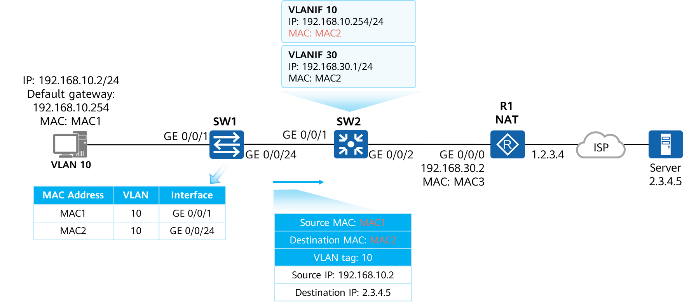

Communication Process (2)

Second,SW1 Processing:

After receiving the frame, SW1 searches the MAC address table for the destination MAC address and forwards the frame.

### Communication Process (3)

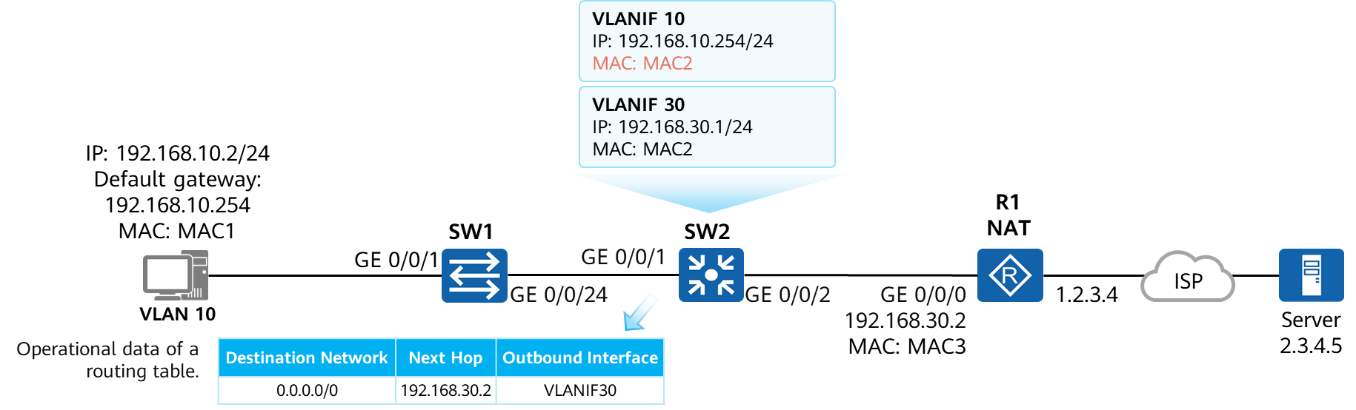

Communication Process (3)-1

Third,SW2 processing:

After SW2 receives the frame, it finds that the destination MAC address is the MAC address of its VLANIF 10 and sends the frame to the routing module, which then searches the routing table for a route matching the destination IP address 2.3.4.5.

After finding that the matching route is a default route, the outbound interface is VLANIF 30, and the next hop is 192.168.30.2, SW2 searches its ARP table to obtain the MAC address corresponding to 192.168.30.2.

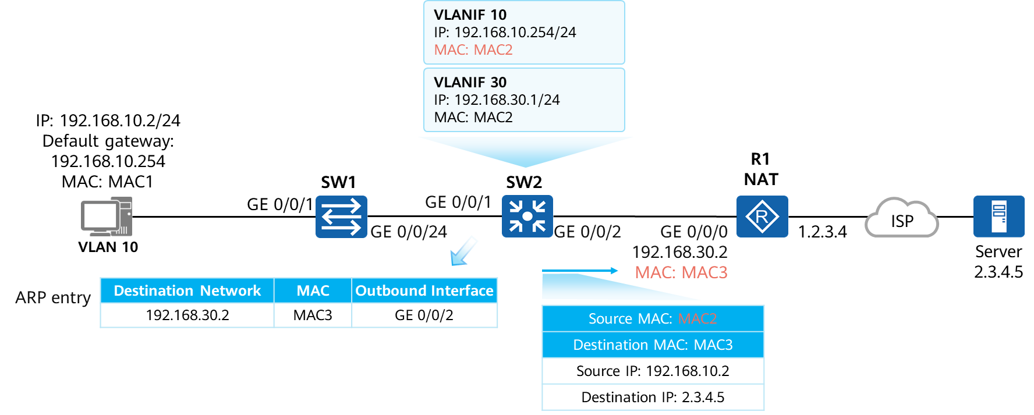

Communication Process (3)-2

After finding the MAC address corresponding to 192.168.30.2, SW2 replaces the source MAC address of the packet with the MAC address of VLANIF 30, and forwards the packet to the switching module. The switching module searches the MAC address table for the outbound interface and determines whether the packet carries a VLAN tag.

### Communication Process (4)

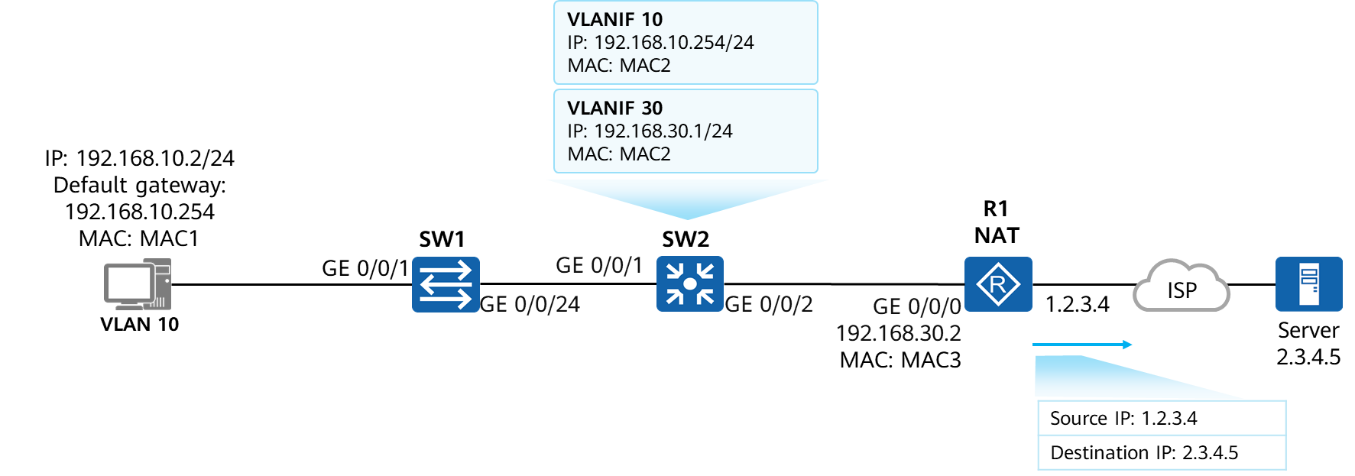

Communication Process (4)

At least,R1 processing:

Checks the destination MAC address of the data packet and finds that the MAC address belongs to its interface. Checks the destination IP address and finds that it is not a local IP address. Searches the routing table, finds a default matching route, and forwards the packet to a carrier device while performing NAT to translate the source IP address and port number of the packet.

Network Address Translation (NAT) translates the IP addresses in IP packet headers to other IP addresses.

## Summary

This course describes three methods of implementing inter-VLAN communication: through physical interfaces, sub-interfaces, and VLANIF interfaces.

It also elaborates the Layer 3 communication process, and device processing mechanism and packet header changes during the communication.

## Quiz

1. (Single) Which of the following statements about a Layer 3 switch is false? ( )
2. Layer 3 switches can only forward packets at Layer 3 but cannot forward packets at Layer 2.
3. Layer 3 switches support routing and forwarding through VLANIF interfaces.
4. A Layer 3 switch can forward both Layer 2 and Layer 3 packets.
5. A Layer 3 switch can implement route forwarding through a Layer 3 physical interface.
6. (Multiple) PC1 belongs to VLAN 10 and its IP address is 192.168.1.1/24. PC2 belongs to VLAN 20 and its IP address is 192.168.1.2/24. Which of the following statements are true? ( )
7. The two PCs can directly access each other.
8. The two PCs cannot directly communicate with each other.
9. After PC1 is changed to VLAN 20, the two PCs can directly communicate with each other.
10. After the IP address of PC2 is changed to 192.168.2.1/24, the two PCs can directly communicate with each other.
11. (True or False) When sub-interfaces are used to implement inter-VLAN communication, the interface connecting the switch to the router must be configured as a trunk interface. ( )
12. True
13. False
14. (True or False) When a Layer 3 switch is used to implement inter-VLAN communication, the VLANIF interface number must be the same as the corresponding VLAN ID. ( )
15. True
16. False
17. (True or False) When implementing inter-VLAN communication, the sub-interfaces of routers and VLANIF interfaces of Layer 3 switches do not process the corresponding tags. ( )
18. True
19. False
20. When a sub-interface is used to implement inter-VLAN communication, how does the switch interface connected to the router need to be configured?
21. Configure the interface as a trunk or hybrid interface to permit packets carrying VLAN tags corresponding to terminals.